Name:
Tutor:
Course:
Date:

Artists in the modern era
In the 21st century, art has been in a dynamic change. A lot of research has been done as well as continuous publication and practice. There has been new thinking and debates to attract people’s contribution with the aim of developing art. New knowledge has led to scholar experimentation, creativity, and innovations
A few questioned purposes of art include recording data. In the modern era, this purpose has been challenged due to an improvement of technology (Gude 6).It is therefore hard to tell a true from a real image in an artwork. The art is also used to display beauty. This purpose has also been questioned since there is no universal definition of beauty. So an art work beauty is limited to the ideals that the observer has concerning beauty (Kan 156). Another purpose of art is storytelling as well as conveying messages.
With the new era, artists experimented and adopted new styles of art.one of them are photorealism. This method was rejected in the advent photography, but today's sculptors have revived it and are now using it in their work. Early photo realists painted images that took after the pop art (Gary 146).Currently, artists can come up with more real pictures compared to the past. Hyperrealism as a style calls for an application of many techniques like colour, scale, and subjects with the aim of not only impressing the viewer but also communicating volumes to them. Example
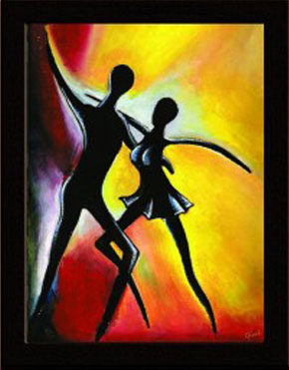

Unlike in the modern era, in the past artist did not modify their works for purposes of passing hidden messages. Surrealism as a style tries to draw the attention of the non-conscious part if the mind. Traditional realism represents artwork that is presented straightforwardly with no hidden meaning. This style has also been used in the modern art just like the conventional art. Contemporary artists also incorporated elements of art like colour, tone, space, scale, and texture to improve their work. The below diagram shows an example of photography
Tarsila do Amaral
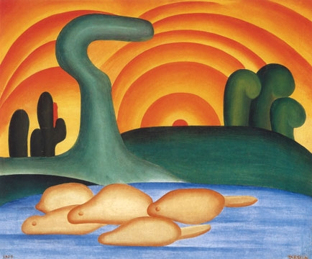
Through January 7, 2018
Galleries 182–84
October 7
History and culture affected the work of these artists. Art encompasses paintings as well as music, sculpting, poetry, and theatre. Depending on culture and traditions, an artist has different driving force towards painting or arts in general. In one part, an artist may use his work to pass messages while another one uses his skills to get money.
Artists are trying their best to incorporate technology into their work to improve the value. Well, they are vision, but the fact remains that physically created artwork is more durable than a computerized network. Limited resources call for skills and talent to complement the digital software. This fissional perspective of the artist differs with their role of passing the message over big time spans.

Work cited
Gury, Al. "Foundations of Drawing: A Practical Guide to Art History, Tools, Techniques, and Styles." (2017).
Gullo, Francesco, et al. "Handling Uncertainty in Clustering Art-Exhibition Visiting Styles." International Conference on Big Data Technologies and Applications. Springer, Cham, 2016
Gude, Olivia. "New school art styles: The project of art education." Art Education 66.1 (2013): 6-15
Frey, Hugo. "Introduction." European Comic Art 9.2 (2016): 1-5.
APA

